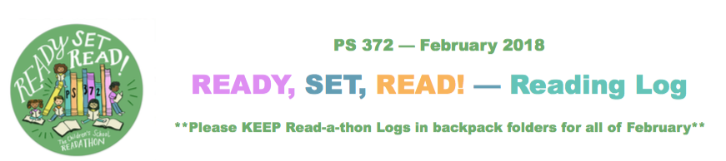Student Name: Grade & Class:
Date | Book Title and Author or Description of Reading Material | # of Mins. Read | Parent / Guardian Initials
Thurs. 2/1
Fri. 2/2
Sat. 2/3
Sun. 2/4
Mon. 2/5
Tues. 2/6
Wed. 2/7
Thurs. 2/8
Fri. 2/9
Sat. 2/10
Sun. 2/11
Mon. 2/12
Tues. 2/13
Wed. 2/14
Wed. 2/14 TALLY DAY | ***Before school on 2/14, Please add all the minutes read thus far and PUT THE SUB-TOTAL HERE ⇒
Please return Logs & Pledge sheets in an envelope via backpack addressed to “PTA Office / Read-a-thon” by Friday 3/2
Student Name: Grade & Class:
Date | Book Title and Author or Description of Readinl | # of Mins. Read | Parent / Guardian Initials
Thurs. 2/15
Fri. 2/16
Sat. 2/17
Sun. 2/18
Mon. 2/19
Tues. 2/20
Wed. 2/21
Thurs. 2/22
Fri. 2/23
Sat. 2/24
Sun. 2/25
Mon. 2/26
Tues. 2/27
Wed. 2/28
TOTAL MINUTES | *** Please add together all minutes read during February and PUT TOTAL HERE ⇒
Please return Logs & Pledge sheets in an envelope via backpack addressed to “PTA Office / Read-a-thon” by Friday 3/2

